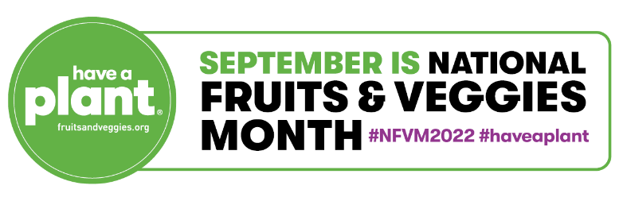

Sample Social Media Posts for National Fruits & Veggies Month 2022*
General NFVM Posts:

- Pop the champagne 🍾 It’s National Fruits & Veggies Month – let’s get our party on!!! There are unlimited ways we can add #fruits & #veggies to our favorite comfort foods, sheet pan dinners, satisfying snacks and more. How will YOU add in one more #plant today? #haveaplant #NFVM2022

- Celebrating National Fruits & Veggies Month looks a bit different for everyone, and that’s a-ok! Whether you’re pairing jicama with a snackable dip, visiting an apple orchard 🍎 or learning more about a local #veggie grower, it’s important to connect with and love the produce you put on your plate. How are YOU celebrating #haveaplant #NFVM2022

- Keep #fruits & #veggies top of mind and #haveaplant every time you eat! Tap into all occasions – shopping, dining out, toasting, biking, playing – and make enjoying #plants fun! Share how you #haveaplant every time in the comments below 💚 #NFVM2022

Make it Easy:
- #DYK that everything we do is based on habits?! Here’s one way to hack your routine to get 👏 more 👏 fruits & veggies 👏 in!
🛒Head to the grocery store & stock up on your staples.
🍴 Do a *tiny* bit of prep. Once home, cut up any fruits & veggies, make some smoothie kits to keep in the freezer, organize canned produce in your pantry, etc.
🤩 Enjoy the smart satisfaction & sweet reward! You’ll be more likely to munch on fruits & veggies throughout the week since most of the prep work is done!
#haveaplant #NFVM2022

Back to Basics:
- Let’s get back to basics & celebrate the art of family meals. 🍽 Everyone’s family here! By enjoying #meals together, you’re creating happier, healthier lives with #fruits & #veggies! After all, people eat more healthfully when they eat together & there are positive behaviors associated with enjoying meals with our loved ones. 💚 #haveaplant #NFVM2022 #familymealsmovement

Fruit & Veggie Hacks:
- Looking for ways to keep your #produce fresh longer, save time ⏰ while cooking meals, or finally master your kitchen organization?! We’ve got you covered! Learn all the best tips & tricks here: https://bit.ly/3zWOs9e Share your favorite #fruit or #veggie hack in the comments below! 👇 #haveaplant #NFVM2022

Fruit & Veggie Care:
- Fruit & veggie care is #selfcare. There’s a sense of pride associated with caring for #fruits & #veggies – just like the care that went into growing them. Farmers & growers are incredible stewards of the land and keep sound #agriculture practices top of mind. Show some 💚 to those who cultivate and create the #produce on our plate 🍽 by purchasing fruits & veggies in all forms, whether fresh, frozen, canned, dried or 100% juice. #haveaplant #NFVM2022

*Sample social media posts are intended for Instagram and Facebook, but can be shortened for posting on Twitter given the limited character count.

