EMAIL TEMPLATE

SUBJECT LINE: 2022 - A Collective Endeavor to Increase Consumption
[Salutation / NAME],
It’s a known challenge that consumers are not eating enough fruits and vegetables. Although many organizations invest in independent efforts, successfully changing consumer behavior is a collective endeavor.
As a partner of the Produce for Better Health Foundation (PBH) – the only 501(c)(3) charitable non-profit organization committed to increasing fruit and vegetable consumption – I’d like to invite your organization to join our community in support of our mission to change the state of the consumer’s plate, filling it with more fruits and vegetables!
It will take a collective endeavor supported by many different organizations and communities for us to achieve success in increasing fruit and vegetable consumption.
Sharese Roper, PBH’s Industry & Partner Engagement Senior Director, is already looking forward to sharing the many ways you and your organization can contribute as part of the PBH community. She can be reached at sroper@pbhfoundation.org or (302) 235-1013.
I encourage you to join the effort. Together, we CAN change fruit and vegetable consumption behavior.

[Signed],

[YOUR name, title and company]

SAMPLE SOCIAL MEDIA POSTS

Engagement efforts with our partners in the produce and health community take place on various social platforms, with the majority being on LinkedIn. PBH welcomes you to use the below sample posts to engage with fellow industry leaders there, as well.

Option 1 | It’s a known challenge that consumers are not eating enough fruits and vegetables. Successfully changing consumer behavior will take a collective effort.  We’ve joined the @Produce for Better Health Foundation (PBH) in support of their work to increase fruits and vegetable consumption.  This is the year for us to come together and create real change.  #community #growconsumption
Option 2 | Join me in supporting the only 501(c)(3) charitable non-profit organization committed to increasing fruit and vegetable consumption, @Produce for Better Health Foundation.  Together, we can create change.  #createchange #growconsumption

SOCIAL MEDIA GRAPHICS
We recommend you use one of the following graphics with your social posts.

Instagram & Facebook
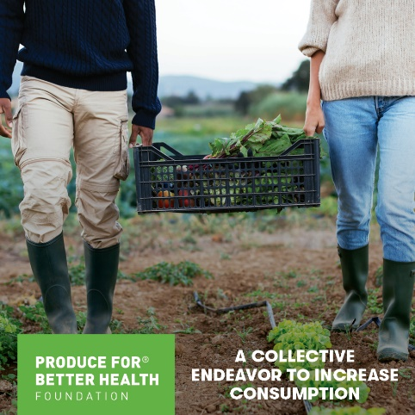 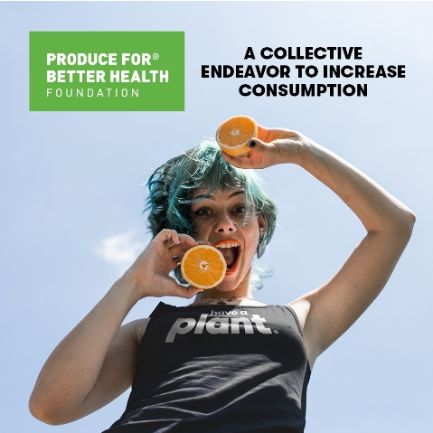
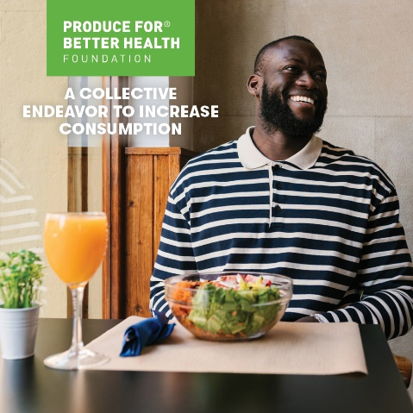
LinkedIn & Twitter
