EMAIL TEMPLATE

SUBJECT LINE: 2022 - A Collective Endeavor to Increase Consumption
[Salutation / NAME],
It’s well known that consumers are not eating enough fruits and vegetables. Your clients invest heavily to challenge consumers through brand marketing to fill their days with more fruit and vegetables, but successfully changing consumer behavior is going to be a collective endeavor.
As a partner of the Produce for Better Health Foundation (PBH) – the only 501(c)(3) charitable non-profit organization committed to increasing fruit and vegetable consumption – I’d like to invite you to consider the opportunities for you and your clients to join their community in support of their work.
I’ve been a partner of PBH for XX years and have seen first-hand the success they’ve had reaching consumers directly. Your clients will benefit from:
- Reaching consumers directly through PBH’s broad portfolio of media channels
- Networking with new business partners across PBH’s partner community
- Growing brand awareness as part of the collective endeavor to increase consumption
Sharese Roper, PBH’s Industry & Partner Engagement Senior Director, is already looking forward to sharing the many ways you and your clients will benefit from becoming a part of the PBH community. She can be reached at sroper@pbhfoundation.org or (302) 235-1013.
You also can download the 2022 PBH Engagement & Education Opportunities for an overview of marketing strategies to create change leveraging PBH’s network.
I encourage you to support the effort. Together, we CAN change fruit and vegetable consumption behavior.

[Signed],

[YOUR name, title and company]

SAMPLE SOCIAL MEDIA POSTS

Engagement efforts with our partners in the produce and health community take place on various social platforms, with the majority being on LinkedIn. PBH welcomes you to use the below sample posts to engage with fellow industry leaders there, as well.

Option 1 | It’s a known challenge that consumers are not eating enough fruits and vegetables. Successfully changing consumer behavior will take a collective effort.  We encourage the food industry to join the @Produce for Better Health Foundation (PBH) in support of their work to increase fruits and vegetable consumption.  This is the year for us to come together and create real change.  #community #growconsumption
Option 2 | It’s a known challenge that consumers are not eating enough fruits and vegetables. Successfully changing consumer behavior will take a collective effort.  The @Produce for Better Health Foundation (PBH) is the only 501(c)(3) charitable non-profit organization committed to increasing fruit and vegetable consumption. We encourage you to join their community and mission in the new year.  #community #moreproduce #fruitsandvegetables #haveaplant
Option 3 | We encourage the food industry to join the @Produce for Better Health Foundation (PBH) in support of their work to increase fruits and vegetable consumption.  Together, we can create change.  #createchange #community #haveaplant

Social Media Graphics
We recommend you use on of the following graphics with your social posts.

Instagram & Facebook
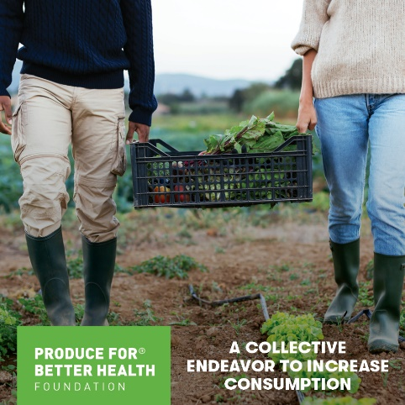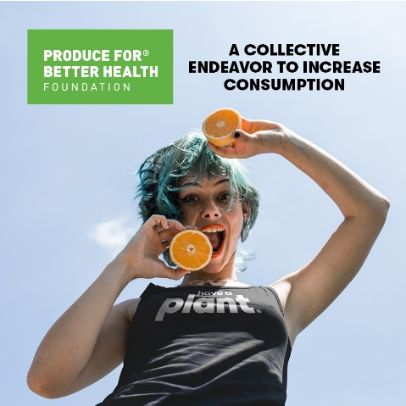
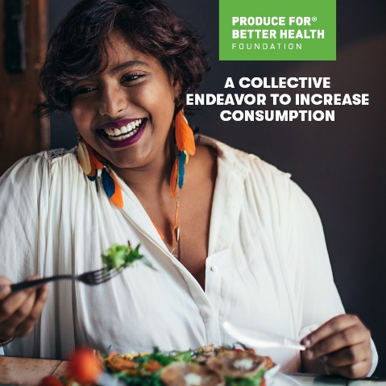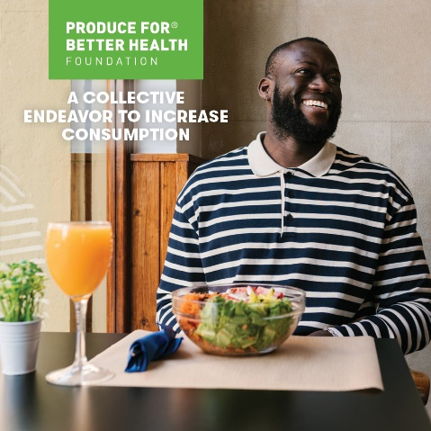

LinkedIn & Twitter
