EMAIL TEMPLATE

SUBJECT LINE: 2022 - A Collective Endeavor to Increase Consumption
[Salutation / NAME],
It’s a known challenge that consumers are not eating enough fruits and vegetables. Your members invest with you to market your one commodity, but successfully changing consumer behavior is going to be a collective endeavor.
As a partner of the Produce for Better Health Foundation (PBH) – the only 501(c)(3) charitable non-profit organization committed to increasing fruit and vegetable consumption – I’d like to invite you and your organization to join me and mine in support of their work to increase fruits and vegetable consumption.
I’ve been a partner of PBH for XX years and have seen first-hand the success they’ve had reaching consumers directly.
Sharese Roper, PBH’s Industry & Partner Engagement Senior Director, is already looking forward to sharing the many ways your organization will benefit from becoming a part of the PBH community. She can be reached at sroper@pbhfoundation.org or (302) 235-1013.
Positive change will lead to a healthier business outlook for our grower partners, farmers and communities. I encourage you to join the effort. Together, we CAN change fruit and vegetable consumption behavior.

[Signed],

[YOUR name, title and company]

SAMPLE SOCIAL MEDIA POSTS

Engagement efforts with our partners in the produce and health community take place on various social platforms, with the majority being on LinkedIn. PBH welcomes you to use the below sample posts to engage with fellow industry leaders there, as well.

Option 1 | It’s a known challenge that consumers are not eating enough fruits and vegetables. Successfully changing consumer behavior will take a collective effort.  We’ve joined the @Produce for Better Health Foundation (PBH) in support of their work to increase fruits and vegetable consumption, including [commodity].  This is the year for us to come together and create real change.  #community #growconsumption
Option 2 | Join me and support the @Produce for Better Health Foundation (PBH). Together, we can change consumer behavior and increase fruit and vegetable consumption.  #haveaplant #growconsumption #community

SOCIAL MEDIA GRAPHICS
We recommend you use one of the following graphics with your social posts.

Instagram & Facebook
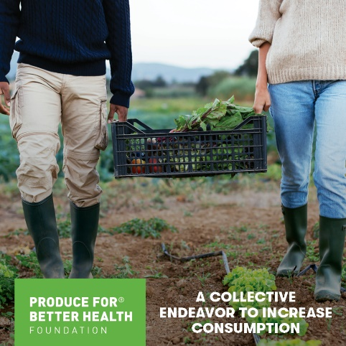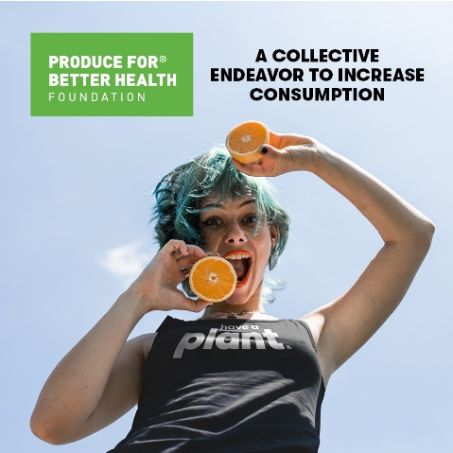

LinkedIn & Twitter
