EMAIL TEMPLATE

SUBJECT LINE: 2022 - A Collective Endeavor to Increase Consumption
[Salutation / NAME],
Across our supply chain, it’s a known challenge that consumers are not eating enough fruits and vegetables. Increasing the consumption of fruits and vegetables cannot be done alone. Successfully changing consumer behavior will take a collective effort.
As a partner of the Produce for Better Health Foundation (PBH) – the only 501(c)(3) charitable non-profit organization committed to increasing fruit and vegetable consumption – I’d like to invite you and your company to join me and mine in support of their work.
Through innovative solutions and creative strategies, I’m confident your voice as part of the PBH community will lead us to success. In partnership with our peers across the food chain, you’ll find value just as I have over my [XX years] of involvement with the organization.
Sharese Roper, PBH’s Industry & Partner Engagement Senior Director, is already looking forward to sharing the many ways you and your company will benefit from becoming a part of the PBH community. She can be reached at sroper@pbhfoundation.org or (302) 235-1013.
I encourage you to join the effort. Together, we CAN change fruit and vegetable consumption behavior.

[Signed],

[YOUR name, title and company]

SAMPLE SOCIAL MEDIA POSTS

Engagement efforts with our partners in the produce and health community take place on various social platforms, with the majority being on LinkedIn. PBH welcomes you to use the below sample posts to engage with fellow industry leaders there, as well.
Option 1 | It’s a known challenge that consumers are not eating enough fruits and vegetables. Successfully changing consumer behavior will take a collective effort across the supply chain.  Join me and the @Produce for Better Health Foundation (PBH) in support of their work to increase fruits and vegetable consumption.  #haveaplant #community #growconsumption
Option 2 | It’s a known challenge that consumers are not eating enough fruits and vegetables. Successfully changing consumer behavior will take a collective effort across the supply chain.  The @Produce for Better Health Foundation (PBH) is the only 501(c)(3) charitable non-profit organization committed to increasing fruit and vegetable consumption.  I’ve been involved with PBH for [XX years]. I encourage you to join me as part of the community taking steps to create real change.  #community #createchange #consumerbehavior
Option 3 | Join me in supporting the only 501(c)(3) charitable non-profit organization committed to increasing fruit and vegetable consumption, @Produce for Better Health Foundation.  Together, we can create change.  #haveaplant #createchange
Option 4 | Join me and support the @Produce for Better Health Foundation (PBH). Together, we can change consumer behavior and increase fruit and vegetable consumption.  #haveaplant #growconsumption

SOCIAL MEDIA GRAPHICS
We recommend you use one of the following graphics with your social posts.

Instagram & Facebook
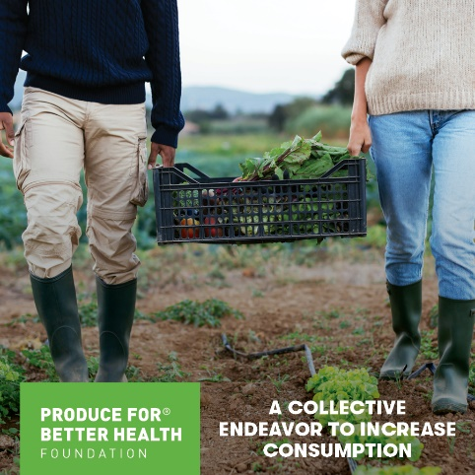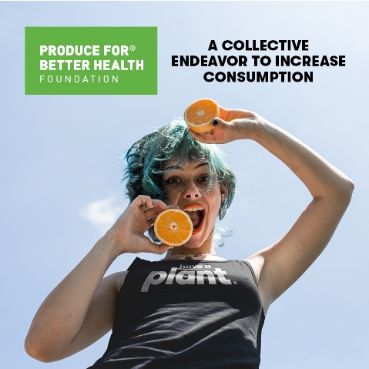
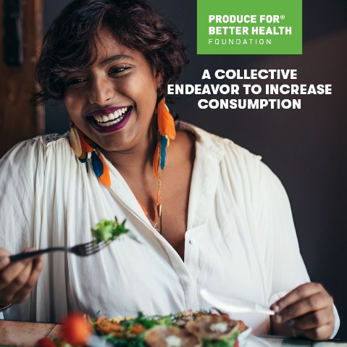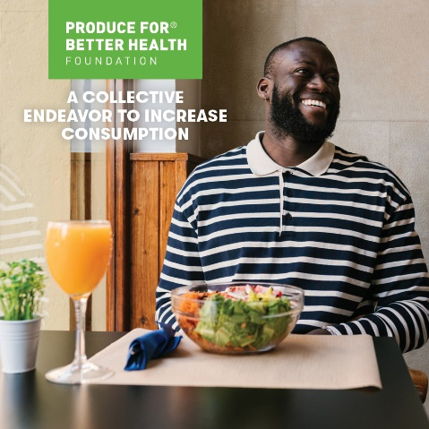

LinkedIn & Twitter
