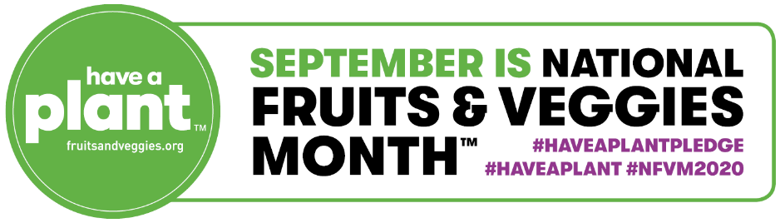

National Fruits & Veggies Month Sample Social Media Posts, September 2020

Sample Social Media Posts

- Would you rather be a hungry pessimist or full optimist? I bet we’d all agree on the answer there. Fruits and veggies have been shown to increase a more positive outlook on life! Let’s get happy! http://bit.ly/2ZianBN @fruitsandveggies #haveaplant #haveaplantpledge #NFVM2020
- September marks the start of National Fruits & Veggies Month, a four-week long celebration of life’s favorite plants – #fruits and #veggies! Join us in taking the Have A Plant™ Pledge. It’s simple. Add more #fruits and/or #vegetables to your daily routine for 30 consecutive days to boost your #health and #happiness. Visit http://bit.ly/2ZianBN to learn more. @fruitsandveggies #haveaplant #haveaplantpledge #NFVM2020
- Now that it's officially National Fruits & Veggies Month, let's take a moment to appreciate all the forms of #fruits and #veggies that you know and love – fresh, frozen, canned, dried and 100% juice – that taste great and are proven to support your health and happiness! Tap the link to learn more: https://bit.ly/2WThXFI @fruitsandveggies #haveaplant #haveaplantpledge #NFVM2020
- Which #fruits and #veggies are you adding to your daily routine during National Fruits & Veggies Month? Snap a pic of those beauties and post it! @fruitsandveggies #haveaplant #haveaplantpledge #NFVM2020
- September is National Fruits & Veggies Month, meaning it’s the perfect time to commit to eating more #fruits and #vegetables each and every day. If you want your food to make you #happier, #healthier, and just generally better, here’s a plan: Have a plant. It’s pretty much as simple as that, and with thousands of convenient options from bushel to freezer to shelf, it’s that easy too. https://bit.ly/2Gu6hz4 @fruitsandveggies #haveaplant #haveaplantpledge #NFVM2020
- Eating fruits and vegetables can benefit your health and may even boost your mood. These colorful creations grew up out of the ground, and they’ve got tons of upside. So, by all means, #haveaplant. Tap the link to learn more. https://bit.ly/2WThXFI @fruitsandveggies #haveaplant #haveaplantpledge #NFVM2020
- So many people are looking for that superfood that’s good for their mind and body. Some are looking really hard. But foods with those benefits are not off in the distant future. They are not a rare delicacy. They are not some secret. They are fruits and vegetables, of any kind. They’re plants. Tap the link to learn more. https://bit.ly/2WThXFI @fruitsandveggies #haveaplant #haveaplantpledge #NFVM2020
- There’s lots of science behind it all, and it boils down to this: if you’re a human being, your body and mind are built to benefit from eating fruits and vegetables, resulting in better health and a better mood. It’s pretty simple: Have A Plant™. Tap the link to learn more. https://bit.ly/2WThXFI @fruitsandveggies #haveaplant #haveaplantpledge #NFVM2020
- Join us today at [name of on-site cafeteria] and #haveaplant with us! Try our [featured plant-based dish] and let us know what you think! Available all month long this National Fruits & Veggies Month. @fruitsandveggies #haveaplant #haveaplantpledge #NFVM2020

- It’s September, which means it’s National Fruits & Veggies Month! What better place to get inspiration of new ways to #haveaplant than fruitsandveggies.org? @fruitsandveggies #haveaplant #haveaplantpledge #NFVM2020
- When is the last time you enjoyed [insert fruit or vegetable]? Well now is the time because [insert fruit or vegetable] is on sale [specify promotion]. Celebrate National Fruits & Veggies Month by picking some up today! @fruitsandveggies #haveaplant #haveaplantpledge #NFVM2020
- Our display of fruits and veggies is a feast for the eyes. Celebrate National Fruits & Veggies Month by stopping in today and picking up your favorites. Visit fruitsandveggies.org for recipe inspiration! @fruitsandveggies #haveaplant #haveaplantpledge #NFVM2020

- Feeling adventurous? Celebrate National Fruits & Veggies Month by finding a new fruit or vegetable in our store today. Check out Fruitsandveggies.org for information on how to select, store, savor, and share this new food! @fruitsandveggies #haveaplant #haveaplantpledge #NFVM2020

We recommend using the following graphics with the sample social media posts:
