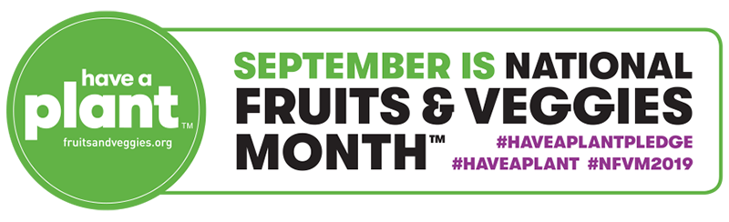
National Fruits & Veggies Month™ Sample Social Media Posts, September 2019

September is National Fruits & Veggies Month™! , a four-week long celebration of life’s favorite plants – fruits and veggies!

Sample Social Media Posts

- Would you rather be a hungry pessimist or full optimist? I bet we’d all agree on the answer there. Fruits and veggies have been shown to increase a more positive outlook on life! Let’s get happy! @fruitsandveggies #haveaplant #haveaplantpledge #NFVM2019

- September marks the start of National Fruits & Veggies Month™, a four-week long celebration of life’s favorite plants – #fruits and #veggies! Join us in taking the Have A Plant™ Pledge. It’s simple. Add more #fruits and/or #vegetables to your daily routine for 30 consecutive days to boost your #health and #happiness. Visit http://bit.ly/2ZianBN to learn more. @fruitsandveggies #haveaplant #haveaplantpledge #NFVM2019

- Now that it's officially National Fruits & Veggies Month™, let's take a moment to appreciate all the forms of #fruits and #veggies that you know and love – fresh, frozen, canned, dried and 100% juice – that taste great and are proven to support your health and happiness! Tap the link to learn how you can get involved: http://bit.ly/2ZbjDwF @fruitsandveggies #haveaplant #haveaplantpledge #NFVM2019

- Which #fruits and #veggies are you adding to your daily routine during National Fruits & Veggies Month™? Snap a pic of those beauties and post it! @fruitsandveggies #haveaplant #haveaplantpledge #NFVM2019

- September is National Fruits & Veggies Month™, meaning it’s the perfect time to commit to eating more #fruits and #vegetables each and every day. This year’s theme is Have A Plant™, Food Rooted in a Better Mood, to reinforce plants’ connection to emotional well-being. Tap the link to learn more: http://bit.ly/2ZbjDwF @fruitsandveggies #haveaplant #haveaplantpledge #NFVM2019

- Put your hand in the air if you L-O-V-E #fruits and #veggies! Grab your limited-edition Have A Plant™ t-shirt before they're gone! http://bit.ly/2NraybM @fruitsandveggies #haveaplant #haveaplantpledge #NFVM2019

We recommend using the following graphics with the sample social media posts:
